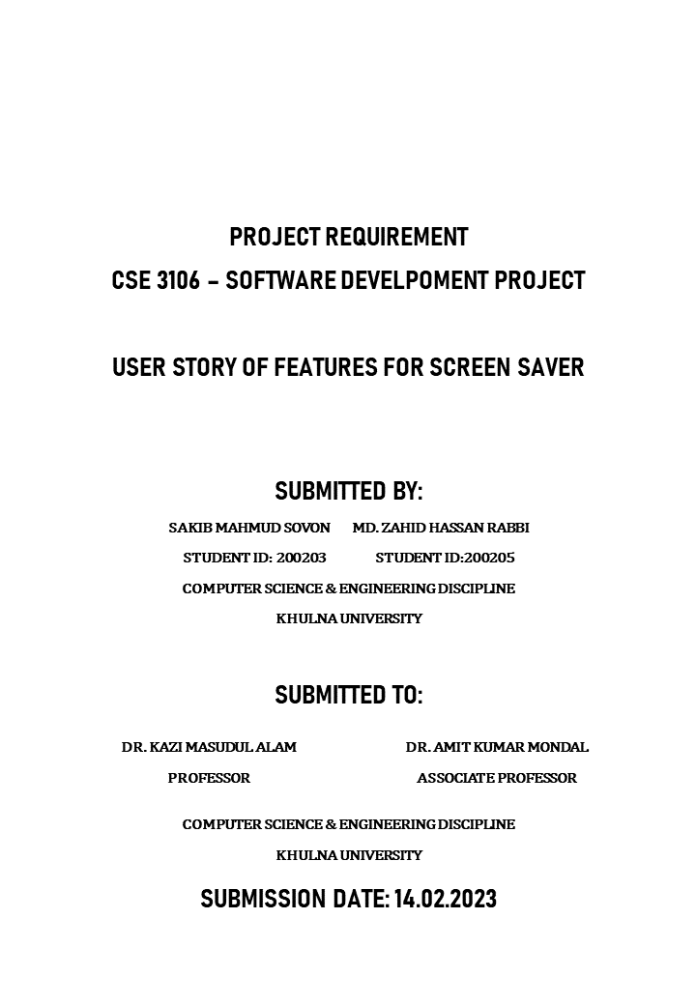

This document outlines the project requirements for a Screen Saver. This project is designed to create a user-friendly and efficient screen saver application for users. We will focus on creating an application that is customizable to meet user needs and preferences, while providing a secure and reliable experience. To ensure the best possible user experience, we will be utilizing the user story format to help us create the most effective features for the application. The user story format will be used to describe the desired functionality and user experience.

**Story Identifier: STI01**

**Description:** As a user, I want to be able to customize the type of screen saver I can set on my laptop, so that I can choose one that best suits my preferences.

**Acceptance Criteria:**

**Functional –**

1. User should be able to select a screen saver from a list of available screen savers.
2. User should be able to customize the duration of the screen saver.

**Non-Functional –**

1. The screen saver should be responsive and compatible with all devices.
2. The screen saver should be easy to use and have a user-friendly interface.

**Story Identifier: STI02**

**Description:** As a user, I want to be able to choose the length of time my laptop is idle before the screen saver activates, so that I can control how long my laptop runs before it is protected.

**Acceptance Criteria:**

**Functional –**

1. User should be able to select the idle time for the laptop from available options.
2. User should be able to customize the idle time.

**Non-Functional –**

1. The idle time settings should persist across system reboots.
2. The idle time settings should be accessible to the user with minimal effort.

**Story Identifier: STI03**

**Description:** As a user, I want to have the option of setting a password for my screen saver, so that I can prevent unauthorized access to my laptop.

**Acceptance Criteria:**

**Functional –**

1. The user should be able to set a password for their screen saver.
2. The user should be able to enter the password to unlock the screen saver.

**Non-Functional –**

1. The password should be securely stored and encrypted.
2. The password should not expire after a certain amount of time.

**Story Identifier: STI04**

**Description:** As a user, I want to be able to easily configure the settings for my screen saver, so that I can quickly adjust the settings when needed.

**Acceptance Criteria:**

**Functional –**

1. User should be able to access the settings page from the main user interface
2. User should be able to enable or disable the screen saver

**Non-Functional –**

1. The user interface should be intuitive and user-friendly
2. The settings page should be responsive and render correctly across different devices

**Story Identifier: STI05**

**Description:** As a user, I want the screen saver to be unobtrusive, so that I can continue working uninterrupted.

**Acceptance Criteria:**

**Functional –**

1. The screen saver should not interfere with the user’s work or disrupt the user’s workflow.
2. The screen saver should contain no distracting animations or sound effects.

**Non-Functional –**

1. The screen saver should have a low resource usage.
2. The screen saver should not negatively affect the user’s computer performance.

**Story Identifier: STI06**

**Description:** As a user, I want to be able to view statistics of my screen saver usage, such as total time used and total number of times activated.

**Acceptance Criteria:**

**Functional –**

1. The system should provide the user with the ability to view overall statistics regarding their screen saver usage, including total time used and total number of times activated.
2. The user should be able to access the statistics at any time.

**Non-Functional –**

1. The screen saver should be able to display the total time used and total number of times activated in a readable format.
2. The statistics should be accurately calculated and updated in real time.